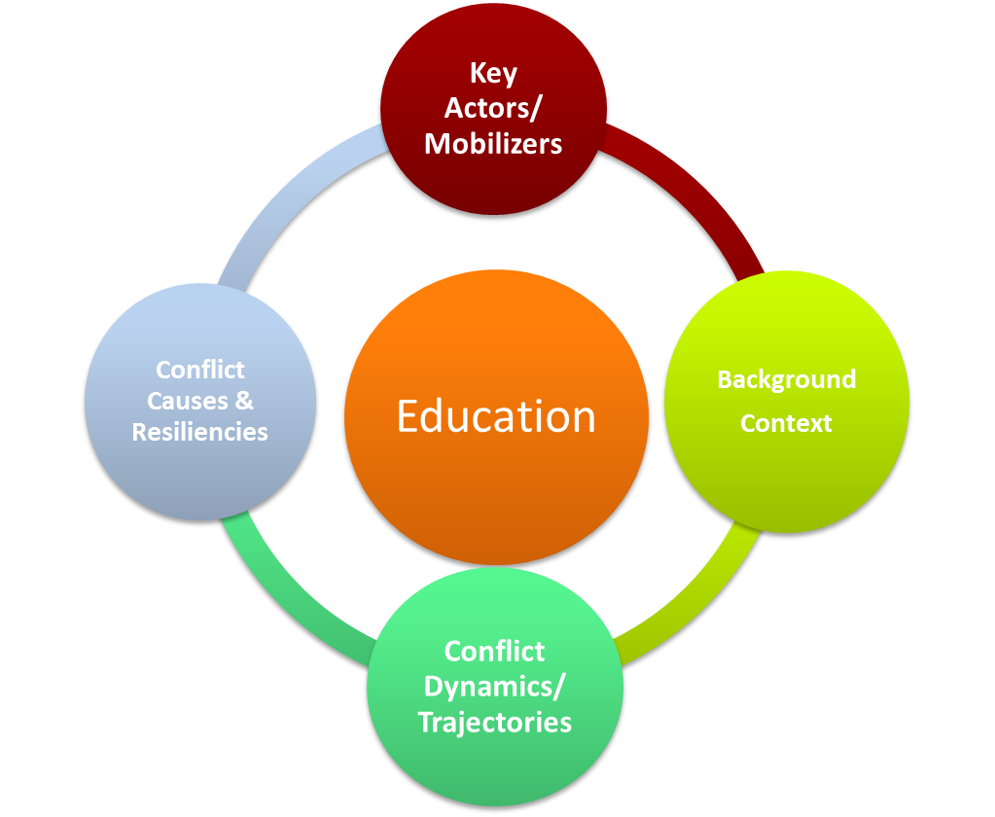
Handout #3A Using Conflict Analysis to Inform Program Design Abbreviated
Instructions:
- Working in your groups, review your respective case study (your own or the one provided on Sierra Leone).

- Reflecting on the findings from the conflict analysis in activity 2, fill in column 2 below with suggestions on what the team should keep in mind when determining the program parameters. If you need more space, write your answers on flip chart paper.
This set of questions has been adapted from the Do No Harm Tool of Collaborative Development Action. More resources may be found on their website http://www.cdacollaborative.org/programs/do-no-harm/

Education Program Parameter Questions | Relevant Conflict Analysis Findings that Should Be Considered
When determining this…  - When will the program be delivered? Why now? How will the schedule relate to local seasons (drought, school year, elections etc.)?  - Where will the program be delivered? What process and selection criteria will be used? What area will not be served, why?  - What resources (training, construction/learning materials, staff, office rentals, and cars) will be brought in? How will they affect the local market?  - With whom will you coordinate and participate? What process and selection criteria will be used?  - For whom will the program be? What process and selection criteria will be used? Who is left out and why?  - Who will you hire? What process and selection criteria will be used? | Consider this…  1.  2.  3.  4.  5.  6.

